Project

In

Literature

“Pain and Agony in the Pursuit of Beauty around the world”

**Ismael, Mohammad Hisham C.**

**MWF-11:30-12:30**

Why men and women suffer so much in physical to achieve the sense of beauty

First of all let’s talk about the plastic surgery addiction? Plastic surgery addiction is a psychological illness where the affected person believes that they can achieve physical perfection through cosmetic surgery. In an attempt to achieve a state of perfect physical beauty, they repeatedly seek out cosmetic surgical procedures to alter their appearance, always believing they're only a surgery away from their imagined ideal. Many people who suffer from plastic surgery addiction are also victims of body dysmorphic disorder where an attractive person believes they're ugly no matter how comely they might appear to other people…

The reason why men and women specifically the teenagers want to achieve beauty for them to please people and of course themselves. Because once you feel that your pretty you are confident to do whatever you want

people nowadays sees what’s outside before the inside. That is why some men and women are willing to the surgery so that they become beautiful and handsome in order to catch the attention of the one they love. After achieving that beautiful appearance, that’s the time they'll see your character…

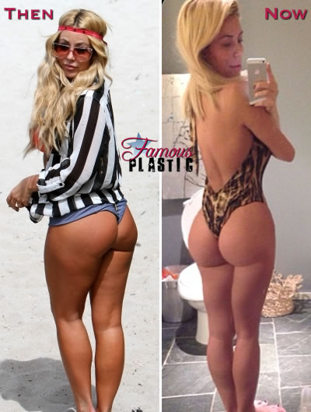

Take one quick look at Aubrey O’Day’s Instagram account and you can see that this girl is seriously obsessed with herself. If you want to see picture after picture of 29-year old Aubrey posing in the bathroom for bikini selfies or pouting desperately into her phone camera, you should totally follow her. Any how, I suppose it should come as no surprise that someone so completely self-absorbed as Aubrey has had plastic surgery, but yes, Aubrey has gone under the knife again, and this time she got a butt augmentation.

Audrey has clearly also had plastic surgery on her butt. It’s hard to tell exactly what she had done, (since her Photoshop skills suck and looking at some of her pictures makes me feel like I’m drunk and underwater…) but we are pretty sure that Aubrey got a Brazilian Butt Lift, which is liposuction with fat transfer to the butt. Another options would be [butt implants](http://famousplastic.net/category/butt-implants/), but I think it’s clear that Aubrey’s new booty is not the result of hard work and good genetics. In **North America and Australia**

By Famous Plastic in [Audrey O'Day](http://famousplastic.net/category/audrey-oday/), [Brazilian Butt Lift](http://famousplastic.net/category/brazilian-butt-lift-2/), [Butt Augmentation](http://famousplastic.net/category/butt-augmentation/), [Butt Injections](http://famousplastic.net/category/butt-injections/), [Fat Transfer](http://famousplastic.net/category/fat-transfer/), [Liposuction](http://famousplastic.net/category/liposuction/)(mutalitation) and [Plastic Surgery](http://famousplastic.net/category/plastic-surgery/)…

  
Surprise, surprise, *Real Housewives of Beverly Hills*star Kyle Richards too, has gone under the knife, and we are realizing now that plastic surgery may actually be a prerequisite to being considered for the role of “real housewife.” The younger sister of [Kim Richards](http://famousplastic.net/category/kim-richards/) – who one-upped Kyle by actually getting her work done on air – has finally admitted to getting cosmetic surgery, including a [nose job](http://famousplastic.net/category/nose-job/) and full-body liposuction, which she says was intended to boost her confidence.  
  
Back in 2006, Kyle Richards opted for a rhinoplasty to alter the nose that she says bothered her for a long time. Not surprisingly, Kyle’s plastic surgeon convinced her that the nose job would be so good that it would look completely natural. “My doctor said, ‘We’re going to do it so slightly, not even your mother will know!’” Well, we’re pretty sure Kyle’s mother noticed her rhinoplasty, as well as her other plastic surgery procedures, along with us and the rest of the world.  
  
After having her nose slimmed down, Kyle went back under the knife in 2012, this time for liposuction. “After having four kids, no matter what exercise I did, the love handles wouldn’t go away,” the RHOBHstar said about her elective surgery. “I wanted to wear jeans and a tucked in shirt and not feel self-conscious.” Although she admits to getting plastic surgery to make herself feel better, Kyle is proud that she hasn’t allowed herself to become a living Barbie doll, like many of her Real Housewivesco-stars. “See, look, I can move my eyebrows,” she joked. “This is a trick in Beverly Hills!” **North America and Australia**

By Meghan in [Kyle Richards](http://famousplastic.net/category/kyle-richards/), [Liposuction](http://famousplastic.net/category/liposuction/)(mutilation) and [Nose Job](http://famousplastic.net/category/nose-job/), [Plastic Surgery](http://famousplastic.net/category/plastic-surgery/) 

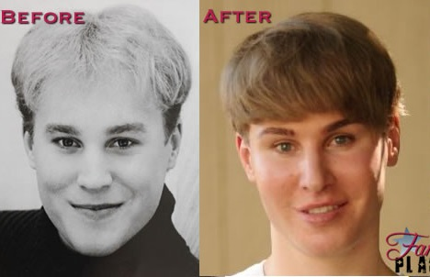

In a desperate attempt to claim the role of Justin Bieber’s doppelganger, a 33-year-old Los Angeles man named Toby Sheldon has undergone $100,000 worth of plastic surgery to look like the Canadian pop star, and he’s not done yet. It’s awkward enough that a grown man would admit to idolizing Justin Bieber, but to subject your body to Botox injections, eyelid surgery, hair implants, a [chin reduction](http://famousplastic.net/category/chin-reduction/) and more [bad plastic surgery](http://famousplastic.net/category/bad-plastic-surgery/) to look like the teenage singer is just plain embarrassing. Even worse, Sheldon doesn’t even listen to Justin Bieber’s music or obsess over him as a celebrity per say; he just finds his face “flawless.”

“Once Justin shot to fame his face was everywhere and all I kept thinking when I saw his picture was, ‘I want to look like him,’” Sheldon admitted. Unlike the thousands of “Beliebers” who probably share this thought on a daily basis though, Sheldon actually decided to go through with it, spending his entire life savings on cosmetic surgery to achieve Bieber’s look. “By using Justin’s charming baby face as my inspiration, I’ve been able to restructure my entire look to maintain a much more youthful appearance through plastic surgery.” Not just any youthful appearance though; Justin Bieber’s youthful appearance.. **North America and Australia**

By Meghan in [Blepharoplasty](http://famousplastic.net/category/blepharoplasty/),[Botox](http://famousplastic.net/category/botox/),[Brow Lift](http://famousplastic.net/category/brow-lift/),[Chin Reduction](http://famousplastic.net/category/chin-reduction/),[Fat Transfer](http://famousplastic.net/category/fat-transfer/),[Hair Restoration](http://famousplastic.net/category/hair-restoration/),[Injectable Fillers](http://famousplastic.net/category/injectable-fillers/),[Justin Bieber](http://famousplastic.net/category/justin-bieber/),[Lip Augmentation](http://famousplastic.net/category/lip-augmentation/),and liposuction(mutilation)

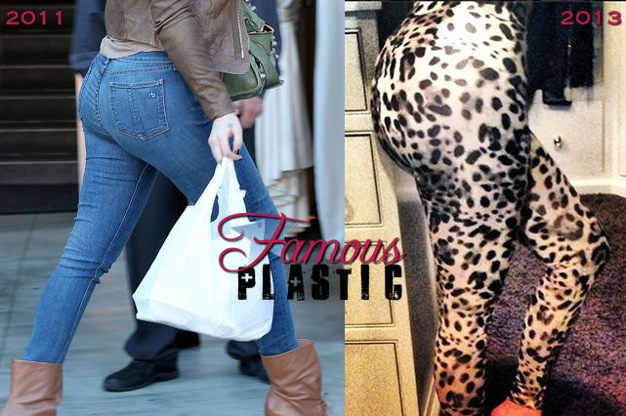Looks like Khloe Kardashian can’t wait to show off her new butt after finally getting butt augmentation surgery! Oh, wait, I mean she’s really excited about the new leopard leggings she got from Sears. Sure, *that’s* why she posted a selfie of her butt to her instagram account. Khloe captioned the picture:

“*I’m loving our @kardashiankollection leopard leggings from Sears! #LeopardLover*”

Khloe, who has always been the odd one out when it came to the curvy Kardashian sisters, finally took the plunge and got a butt augmentation surgery, which has taken her formerly flat, square butt and plumped it to proportions that rival her sister Kim’s booty. In addition to the super-sized booty, Khloe now also has a flat-as-a-board stomach, which leads us to believe that she underwent the same surgery as Kim: liposuction with fat transfer to the butt.

We couldn’t help but notice that [Khloe took to wearing padded panties](http://famousplastic.net/2011/10/15/khloe-kardashian-wears-padded-panties/) a couple of years ago, but it looks like she has opted for a more permanent solution and recently had plastic surgery to increase the size of her butt Perhaps since [Kim Kardashian](http://famousplastic.net/category/kim-kardashian/)‘s boyfriend Kanye West has made Kim slow down the fame-whore train that is all things Kardashian, Kris Jenner must be calling upon Khloe to pick up her slack.  
. **North America and Australia**

By Maya in [Butt Augmentation](http://famousplastic.net/category/butt-augmentation/),[Fat Transfer](http://famousplastic.net/category/fat-transfer/),[Khloe Kardashian](http://famousplastic.net/category/khloe-kardashian/),[Liposuction](http://famousplastic.net/category/liposuction/)(mutilation) and [Plastic Surgery](http://famousplastic.net/category/plastic-surgery/)

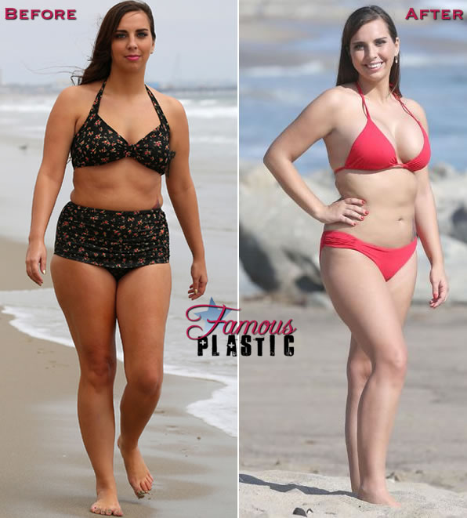

Sydney Leathers, the woman who busted Anthony Weiner for sexting, went ahead and got her plastic surgery makeover. And, apparently there was a lot of making over to be done, because she blew $40,000 on several different procedures!

The unemployed 23-year old, who dropped out of college because she was busy making and promoting her p0rnos, spent $40,000 on a [nose job](http://famousplastic.net/category/nose-job/), breast implants, liposuction and cosmetic dentistry. Sydney chose to undergo all three surgeries in one day and her plastic surgery makeover took 5 hours to perform. Plastic surgeon Dr. Matthew Schulman performed the surgeries on Sydney, which removed a bump from her nose, 5lbs of fat from her gut and increased her bust size from a C-cup to a D-cup. Sydney also opted to have her teeth whitened and debuted her new look in a red bikini as she posed for photographers on the beach.. **North America and Australia**

By Famous Plastic in [Boob Job](http://famousplastic.net/category/boob-job/), [Breast Augmentation](http://famousplastic.net/category/breast-augmentation/), [Breast Implants](http://famousplastic.net/category/breast-implants-2/), [Cosmetic Dentistry](http://famousplastic.net/category/cosmetic-dentistry/), [Liposuction](http://famousplastic.net/category/liposuction/)(mutilation), [Nose Job](http://famousplastic.net/category/nose-job/), [Plastic Surgery](http://famousplastic.net/category/plastic-surgery/) and [Rhinoplasty](http://famousplastic.net/category/rhinoplasty/)

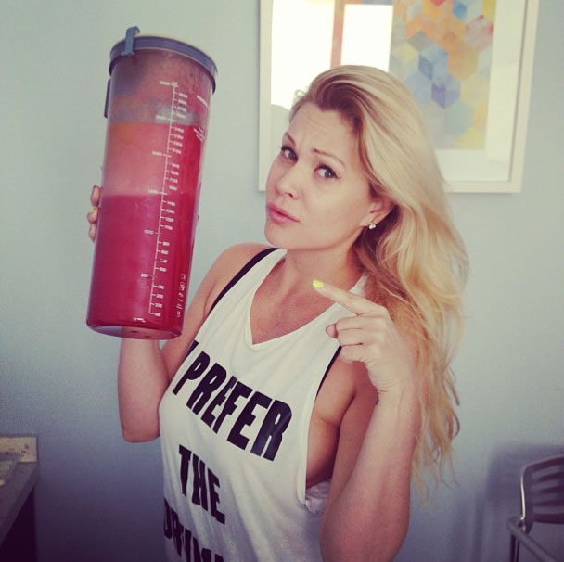

Shanna Moakler wants to show you something…The 2.5 liters of bloody fat that she just got suctioned out of her body!  
  
Shanna Moakler posted the picture above shortly after having “Airbrush Laser Liposculpture”, which is a fancy name for liposuction, on her waistline. Shanna is extremely happy with the procedure and decided to undergo liposuction after three pregnancies and three c-sections left her unable to snap back into pre-pregnancy shape.

Shanna, who is a model, beauty queen and ex-wife of drummer Travis Barker, had the procedure done by Beverly Hills plastic surgeon Dr. Aaron Rollins and she couldn’t be happier with the surgery and the results. According to Shanna, the liposuction was painless, took only 30 minutes and she was awake for the procedure. Granted, this is what Shanna said immediately following the surgery, so let’s see how she feels tomorrow, when those happy pain meds wear off. From what we’ve heard first hand, liposuction is extremely painful… **North America and Australia**

By Famous Plastic in [Dr. Aaron Rollins](http://famousplastic.net/category/dr-aaron-rollins/), [Liposuction](http://famousplastic.net/category/liposuction/) (mutilation)

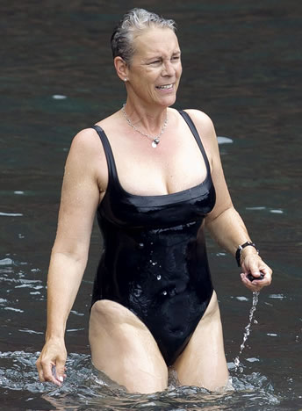Apparently Jamie Lee Curtis has sworn off Botox and plastic surgery, but we’re having a hard time believing her, since the 54-year-old actress already gave plastic surgery the boot once before, back in 2006, when she said the work she had done made her look “weird.” According to “then” Jamie, undergoing cosmetic surgery was the worst decision she had ever made – a “horrible experience” that made her much more insecure than she already was. If Jamie Lee really means it this time though, kudos to her. It’s never a bad idea for a grown woman to practice some self-acceptance.

Jamie Lee Curtis, like many other unfortunate actresses, got caught up in the plastic surgery game way back when and has undergone a number of cosmetic surgery procedures in the years since, including liposuction, [blepharoplasty](http://famousplastic.net/category/blepharoplasty/), breast implants, Botox and more. Unlike other plastic surgery-obsessed celebrities out there though, Jamie has the guts to tell it like it is. “I’ve had a little plastic surgery. I’ve had a little lipo. I’ve had a little Botox,” Jamie Lee says. “And you know what? None of it works. None of it.”

In addition to becoming a little obsessed with cosmetic surgery itself, Jamie Lee also developed an addiction to pain medication after undergoing [bad plastic surgery](http://famousplastic.net/category/bad-plastic-surgery/), which she says made her feel unnatural. The first time she had painkillers was during a cosmetic procedure, and she became hooked on the pills after plastic surgery failed to improve her appearance, anesthetizing herself on a daily basis just to get by. **North America and Australia**  
By Meghan in [Blepharoplasty](http://famousplastic.net/category/blepharoplasty/), [Boob Job](http://famousplastic.net/category/boob-job/), [Botox](http://famousplastic.net/category/botox/), [Breast Augmentation](http://famousplastic.net/category/breast-augmentation/), [Breast Implants](http://famousplastic.net/category/breast-implants-2/), [Injectable Fillers](http://famousplastic.net/category/injectable-fillers/), [Jamie Lee Curtis](http://famousplastic.net/category/jamie-lee-curtis/), [Liposuction](http://famousplastic.net/category/liposuction/)(mutilation), [Plastic Surgery](http://famousplastic.net/category/plastic-surgery/)

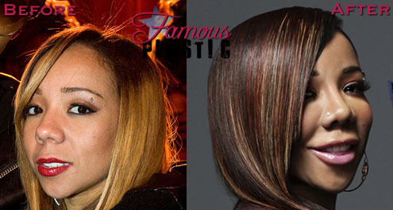

Tameka “Tiny” Cottle shot to fame in the 90′s when she was a member of multi-platinum selling R&B group “Xscape”. Currently, it looks like she needs to escape from the clutches of her plastic surgeon…  
  
Tiny, who is married to rapper TI, hit our [bad plastic surgery](http://famousplastic.net/category/bad-plastic-surgery/) radar with her extreme ducklips, but after digging up some old photos of the singer/songwriter, the inflated lips are just a tiny part of Tiny’s plastic surgery transformation. At 37-years old, Tiny appears to be plasticly revamped from head to toe. So what exactly has Tiny had done? It appears that she has had a [nose job](http://famousplastic.net/category/nose-job/), lip augmentation, cheek augmentation, filler injections, Botox, breast implants, liposuction, tummy tuck and butt augmentation.  
  
Tiny has certainly had way too much plastic surgery and it shows. But where exactly did she go wrong? As far as her face goes, we think that the plastic surgeon that did her nose job was far too aggressive and her nose looks too small and very obviously worked on. Also, judging from her joker-like smile, it appears that Tiny’s ducklips are the result of lip implants (which just never look right! See [Meg Ryan](http://famousplastic.net/category/meg-ryan/)). As for her body, Tiny stands only 4’11″ tall, so the large breast implants and super-sized booty just look out of place and a little bit ridiculous, especially when compared to her “Xscape” days, when she was flat as a board.. **North America and Australia**  
  
By Famous Plastic in [Bad Plastic Surgery](http://famousplastic.net/category/bad-plastic-surgery/), [Boob Job](http://famousplastic.net/category/boob-job/), [Botox](http://famousplastic.net/category/botox/), [Breast Augmentation](http://famousplastic.net/category/breast-augmentation/), [Breast Implants](http://famousplastic.net/category/breast-implants-2/), [Butt Augmentation](http://famousplastic.net/category/butt-augmentation/), [Butt Injections](http://famousplastic.net/category/butt-injections/), [Injectable Fillers](http://famousplastic.net/category/injectable-fillers/), [lip implants](http://famousplastic.net/category/lip-implants/), [Liposuction](http://famousplastic.net/category/liposuction/), [Plastic Surgery](http://famousplastic.net/category/plastic-surgery/), [Rhinoplasty](http://famousplastic.net/category/rhinoplasty/), [Tameka "Tiny" Cottle](http://famousplastic.net/category/tameka-tiny-cottle-2/), [trout pout](http://famousplastic.net/category/trout-pout/), [Tummy Tuck](http://famousplastic.net/category/tummy-tuck/)

“Famous plastic and liposuction” Reserved January 23 2014

From <http://famousplastic.net/>

“Famous plastic and liposuction” Reserved November 4 2013

From <http://famousplastic.net/>

“Famous plastic and liposuction” Reserved October 23 2013

From <http://famousplastic.net/>

“Famous plastic and liposuction” Reserved October 22 2013

From <http://famousplastic.net/>

“Famous plastic and liposuction” Reserved September 06 2013

From <http://famousplastic.net/>

“Famous plastic and liposuction” Reserved September 04 2013

From <http://famousplastic.net/>

“Famous plastic and liposuction” Reserved August 23 2013

From <http://famousplastic.net/>

“Famous plastic and liposuction” Reserved December 24 2012

From <http://famousplastic.net/>